7.1 – 7.7 Testing Report

1. Change smoking sentence

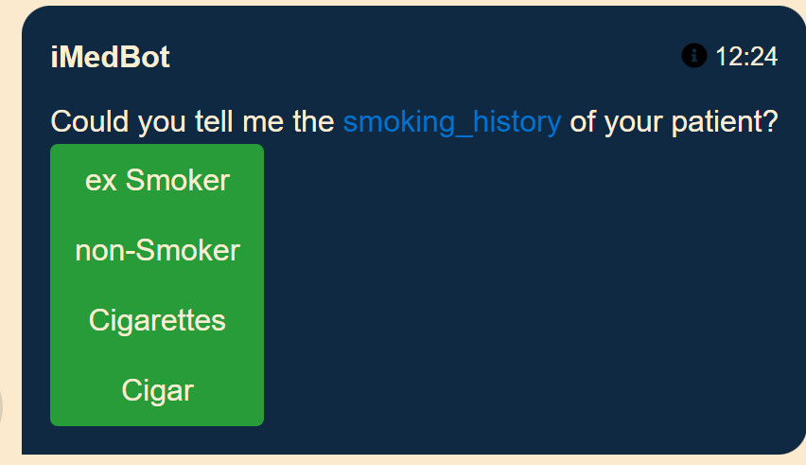

Before After

Not break the links

3.

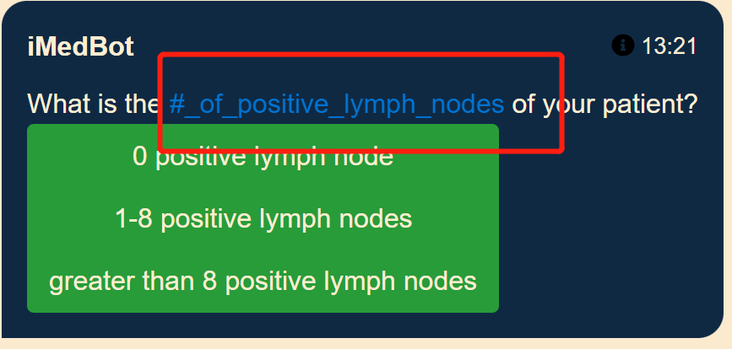

Before After

No break links, just the term.

4. n_tnm_stage cannot be changed



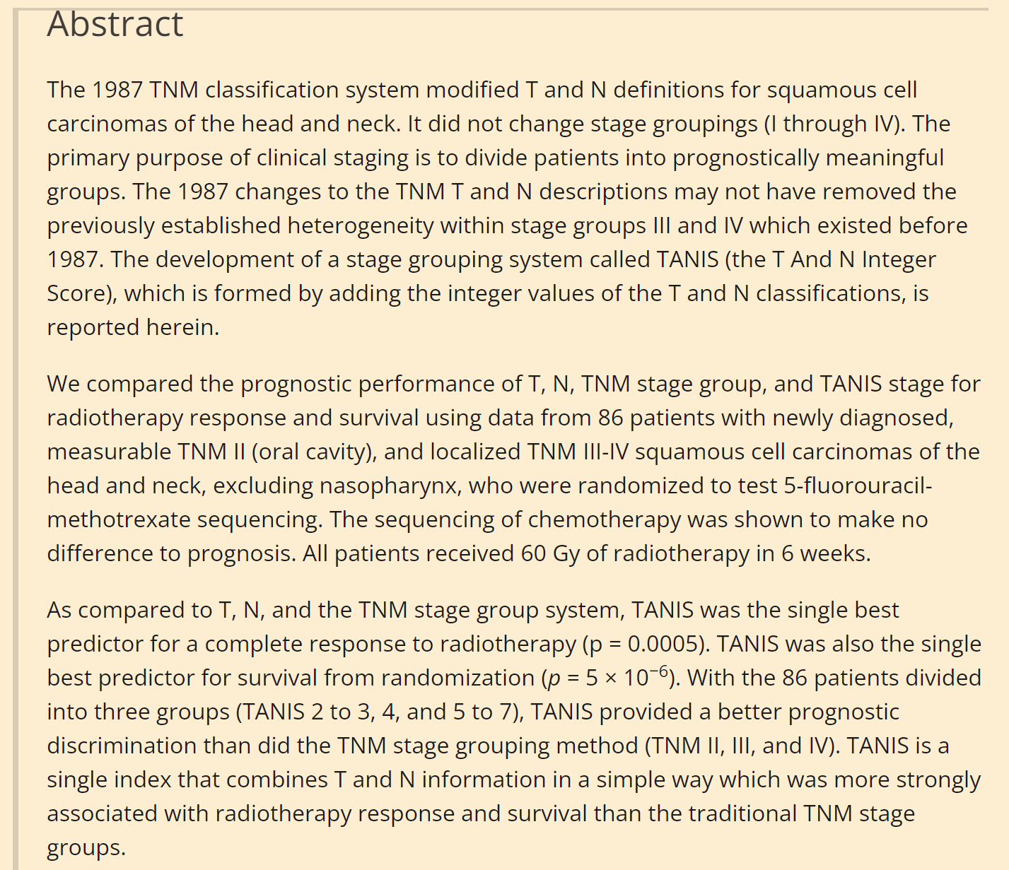

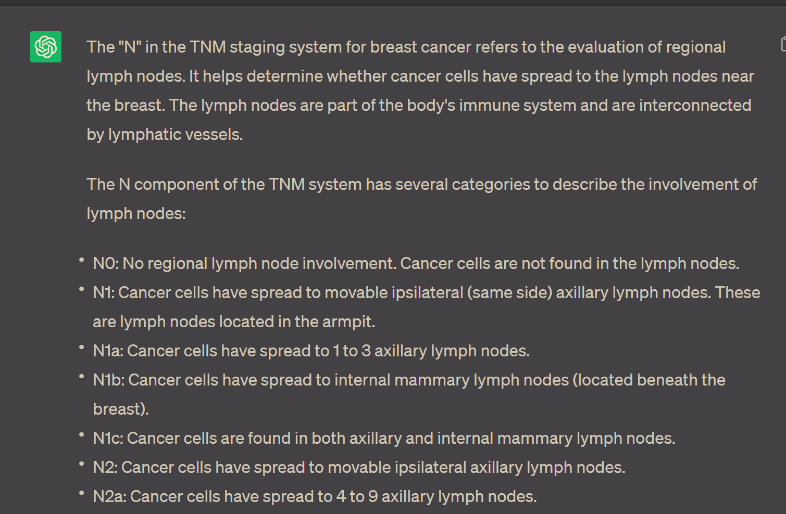

5. stage



I think here should be refined.

6.

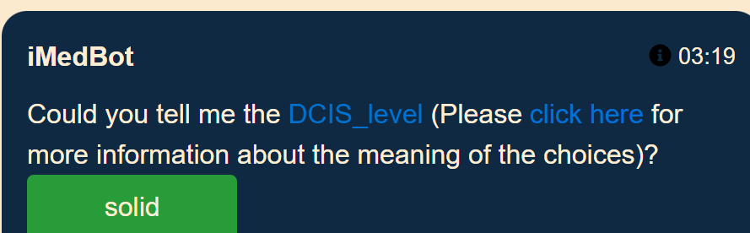

Before After

7. grade

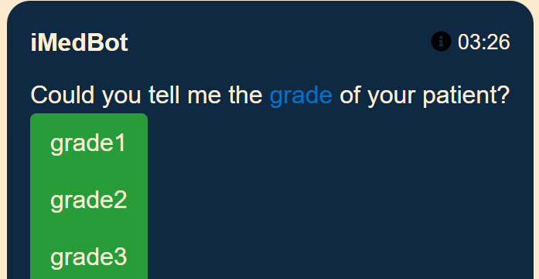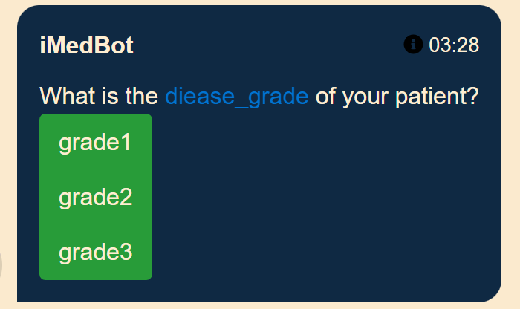

Before After

8.

Cannot make changes for surgical_margins, it will break the link.

9.

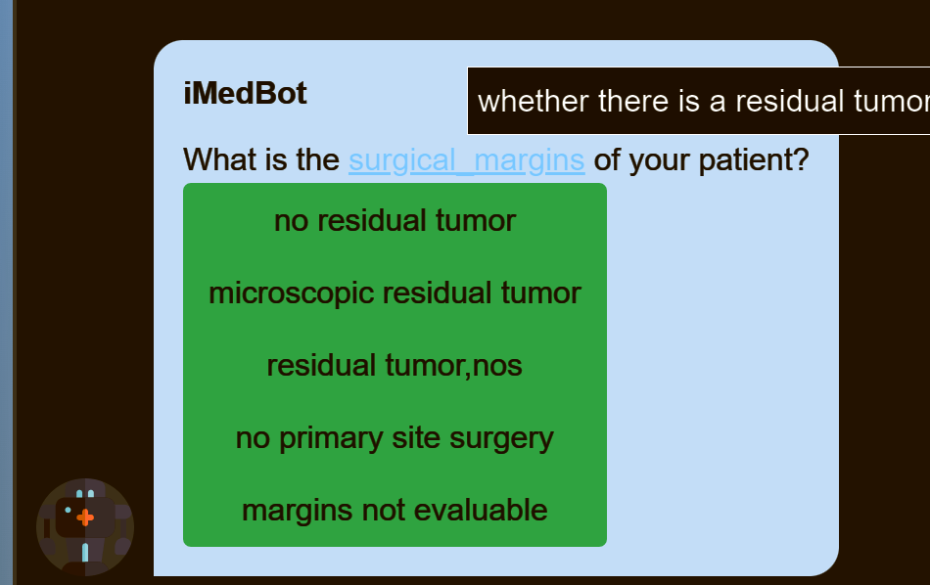

Before

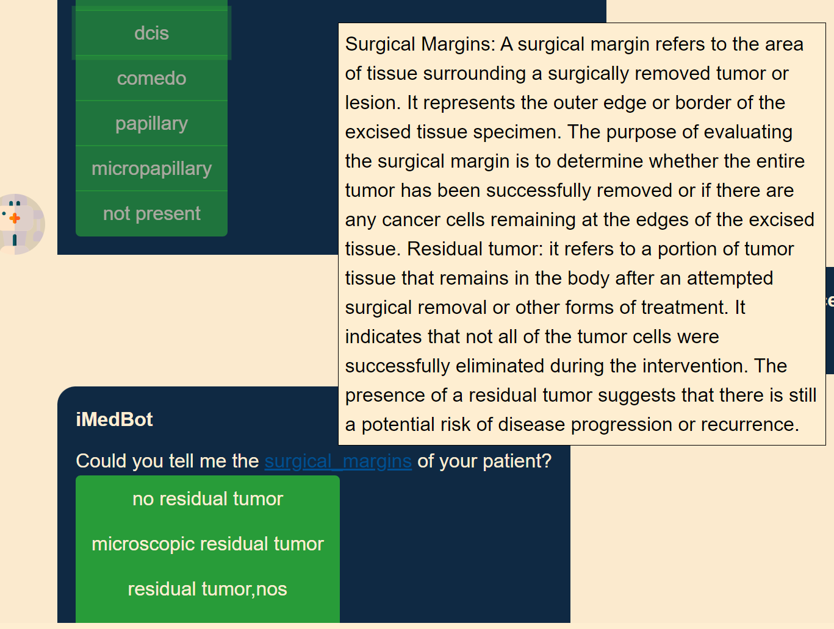

After